Sampling Exercises
Charley Kirk
10/25/2024
If you knit this document, you will see the notation that is used for sampling. You might want to knit to a Word document and then have both the Word document and this file open at the same time.
ModernDive is under a Creative Commons Attribution - NonCommercial - ShareAlike 4.0 license so it is able to be modified with attribution as above. These are exercises based partially on the Learning Checks in ModernDive.
This assignment is based on one by Albert Kim and Jenny Smetzer designed to accompany the book.

Background
For this exercise, we will mimic the tactile sampling you read with virtual sampling. We will use some data from the general social survey, an annual personal-interview survey conducted in the United States. The survey is designed to monitor changes in both social characteristics and attitudes.
For this exercise, the population of interest will be ALL 2538 individuals living in a single neighborhood in 2014. As an analogy to the tactile sampling, the neighborhood is the “bowl” and the 2,538 people are the little balls.
If you get stuck as you are working through this Problem Set, we strongly recommend you re-read Chapter 7, Sampling, in ModernDive, in particular subsections 7.3.1 on “Terminology & notation” and 7.3.2 on “Statistical definitions”. These terminology, notation, and definitions related to sampling are definitely tricky at first; the best method to master them is practice, practice, practice.

Key points on symbols:
If you want to see the symbols, knit the document and look there.
Symbol | POPULATION PARAMETER | SAMPLE PARAMETER
Number of cases | $N$ | $n$
Proportion | $p$ | $\hat{p}$
Standard error | $SE$ | $\hat{SE}$

Setup
First load the necessary packages:
library(ggplot2)
library(dplyr)
library(forcats)
library(moderndive)
You can load and take a glimpse() of the gss_cat data set in the forcats package like so:
gss_cat
glimpse(gss_cat)

Exploratory data wrangling
This data set includes many years of data, and many variables. To start, we will restrict our analysis to only 2014, and to only the variable indicating the marital status of each respondent.
gss_14 <- gss_cat %>%
filter(year == 2014) %>%
select(marital)
The following shows the different responses for marital status:
gss_14 %>%
distinct(marital)
## # A tibble: 6 × 1
## marital
## <fct>
## 1 Divorced
## 2 Married
## 3 Never married
## 4 Separated
## 5 Widowed
## 6 No answer

Setting a seed
Setting a seed: We will take some random samples in this Problem Set. In order to make sure R takes the same random sample every time you run your code, you can do what is called “setting a seed”. Do this in any code chunk that you take a random sample!
You can set a seed like so. Any number will do. (You do not need to run this right now…just showing you how). By setting the seed you are telling the random number generator where to “start.” If you do not set a seed the “start” will be randomly generated. Usually that random start is fine. However, if you want to get the same answers when you are using random number generators, you set a seed so that you get the same set of random numbers each time you run the code.
set.seed(42) #Guess why it is 42 if you'd like.

The true population proportion $p$ of divorced people
Again, for this exercise, the population of interest will be ALL 2538 individuals living in this single neighborhood in 2014. Since we have data on ALL 2538 people living in the neighborhood, we can compute the exact population proportion $p$ of divorced people directly like so, using ALL the data:
gss_14 %>%
summarize(divorced = sum(marital == "Divorced"),
N = n()) %>%
mutate(p = divorced / N)
## # A tibble: 1 × 3
## divorced N p
## <int> <int> <dbl>
## 1 411 2538 0.162
Note that we use $N$ for the size of the full population of 2538 people, and $p$ because we are calculating the TRUE population proportion $p$
Note that no inference to the population is needed. We do not need to use a sample to try to infer something about the true population proportion $p$ of divorced people in this neighborhood in 2014. We know that $p$ = 0.16.
In other words, this assignment is not a realistic reflection of a real life problem. However, for this problem set, we are simulating the act of sampling from this neighborhood population to understand and study how factors like sample size influence sampling variation.

Demo: sampling 50 people in the neighborhood

a) Estimating $\hat{p}$ from a single sample
We are first going to use random sampling to ESTIMATE the true population proportion $p$ of the neighborhood that are divorced with only a sample of 50 people.
This will represent a situation of only having the resources to knock on 50 doors to get responses from people in this neighborhood!
set.seed(42)
n50_1rep <- gss_14 %>%
rep_sample_n(size = 50, reps = 1)
n50_1rep
## # A tibble: 50 × 2
## # Groups: replicate [1]
## replicate marital
## <int> <fct>
## 1 1 Married
## 2 1 Divorced
## 3 1 Married
## 4 1 Married
## 5 1 Widowed
## 6 1 Married
## 7 1 Never married
## 8 1 Widowed
## 9 1 Married
## 10 1 Never married
## # ℹ 40 more rows
Next, let’s calculate the sample proportion $\hat{p}$ of people who identified as Divorced in our sample of 50 people.
n50_1rep %>%
summarize(divorce_count = sum(marital == "Divorced"),
n = n()) %>%
mutate(p_hat = divorce_count/ n)
## # A tibble: 1 × 4
## replicate divorce_count n p_hat
## <int> <int> <int> <dbl>
## 1 1 8 50 0.16
This sample proportion $\hat{p}$ is an ESTIMATE, and our best guess of what the true population proportion $p$ of Divorced people is in this neighborhood, based on a sample of only 50 people. It is reasonably close to the true population proportion $p=0.16$ we calculated from the full population.

Question 1a
Copy and paste the code above twice and change the seed for each paste. What sample proportions did you get?
Answer:
set.seed(65)
n50_1rep <- gss_14 %>%
rep_sample_n(size = 50, reps = 1)
n50_1rep %>%
summarize(divorce_count = sum(marital == "Divorced"),
n = n()) %>%
mutate(p_hat = divorce_count/ n)
## # A tibble: 1 × 4
## replicate divorce_count n p_hat
## <int> <int> <int> <dbl>
## 1 1 10 50 0.2
set.seed(67)
n50_1rep <- gss_14 %>%
rep_sample_n(size = 50, reps = 1)
n50_1rep %>%
summarize(divorce_count = sum(marital == "Divorced"),
n = n()) %>%
mutate(p_hat = divorce_count/ n)
## # A tibble: 1 × 4
## replicate divorce_count n p_hat
## <int> <int> <int> <dbl>
## 1 1 5 50 0.1
I got sample proportions of 0.2 and 0.1.

Question 1b
Why did each sample get a different estimate?
Answer:
Because each sample used a different random selection of 50 marital statuses.

b) Estimating $\hat{SE}$ from a single sample
Typically we only have the opportunity to collect one sample for our study, and so we have to use the amount of variability in our single sample as an estimate of the amount of variability we might expect in our results if we had taken a random sample of 50 different people. The ${\hat{SE}}_{\hat{p}}$ serves as an ESTIMATE of sampling variability if you only have a single sample. The formula for estimating the standard error of $\hat{p}$ is the following:
$${\hat{SE}}_{\hat{p}}≈\sqrt{\frac{\hat{p}×\left(1−\hat{p}\right)}{n}}$$
Note that we use $n$ for the size of the sample, that p “wears a hat”, like so: $\hat{p}$ because we are ESTIMATING a proportion based on only a sample, and that the SE “wears a hat” as well because we ESTIMATING $\hat{SE}$ based on only a sample. This estimate only works well when the sample is large enough, more on that later.
The standard error of $\hat{p}$ can be estimated in R like so:
n50_1rep %>%
summarize(divorce_count = sum(marital == "Divorced"),
n = n()) %>%
mutate(p_hat = divorce_count/ n,
se_hat = sqrt(p_hat * (1 - p_hat) / n))
## # A tibble: 1 × 5
## replicate divorce_count n p_hat se_hat
## <int> <int> <int> <dbl> <dbl>
## 1 1 5 50 0.1 0.0424

Demo: Generating a sampling distribution of $\hat{p}$
Pay special attention to the value of n and the number of repetitions as you work through this material.
If you ran the code chunk that takes a random sample of 50 cases a thousand more times….and wrote down every $\hat{p}$ you got, you would have what is called a “sampling distribution”.
A sampling distribution shows every [or nearly every!] possible result a sampling statistic can have under every [or nearly every!] possible sample of a given sample size from a population.

a) Sampling distribution of $\hat{p}$ for n = 50
Instead of running the sampling code chunk for n = 50 over and over, we can “collect” 1000 samples of n = 50 really easily in R. The following code chunk takes 1000 different samples of n = 50 and stores them in the data frame n50_1000rep:
set.seed(19)
n50_1000rep <- gss_14 %>%
rep_sample_n(size = 50, reps = 1000)
Be sure to look at n50_rep1000 in the data viewer to get a sense of what these 1000 samples look like.

Question 2a
What is the name of the column that identifies which of the 1000 samples each row is from?
Answer:
The name of the column is replicate.

Question 2b
What is the sample size n for each of the 1000 samples we took? (i.e. how many humans are sampled in each replicate)?
Answer:
The sample size is 50.

The following code chunk calculates the sample proportion $\hat{p}$ of people who reported they were divorced for each of the 1000 samples
set.seed(42)
p_hat_n50_1000rep <- n50_1000rep %>%
group_by(replicate) %>%
summarize(divorce_count = sum(marital == "Divorced"),
n = n()) %>%
mutate(p_hat = divorce_count / n)
Take a look at the first five rows of the results:
p_hat_n50_1000rep %>%
slice(1:5)
## # A tibble: 5 × 4
## replicate divorce_count n p_hat
## <int> <int> <int> <dbl>
## 1 1 4 50 0.08
## 2 2 5 50 0.1
## 3 3 8 50 0.16
## 4 4 9 50 0.18
## 5 5 10 50 0.2

b) Visualize the sampling distribution of $\hat{p}$ for n = 50
We can plot the sampling distribution of these 1000 $\hat{p}$ estimates of divorced respondents with a histogram, like so:
ggplot(p_hat_n50_1000rep, aes(x = p_hat)) +
geom_histogram(binwidth = 0.02, color = "black", fill = "aquamarine3") +
labs(x = "Sample proportion of divorced respondents",
title = "Sampling distribution of p-hat based on n = 50")
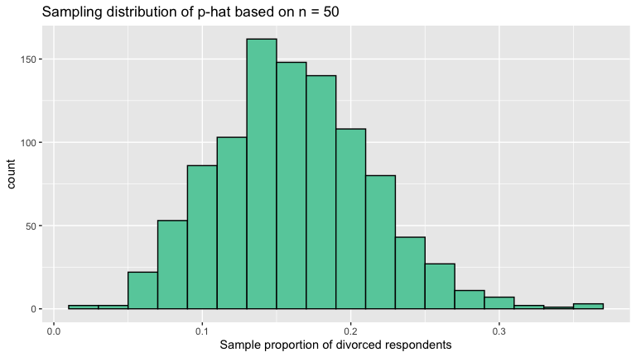

Question 3
Based on your histogram, what appeared to be a very common value of $\hat{p}$? What was a very uncommon value?
Answer:
0.15 was probably a pretty common value. 0.35 was probably a pretty uncommon value.

c) Mean and standard error of the sampling distribution of $\hat{p}$ for n = 50
Note that the histogram above is relatively mounded and symmetrical. We can estimate the mean of the sampling distribution (appropriate since the distribution is mounded and symmetrical) by calculating the mean of all 1000 $\hat{p}$ estimates, and the standard error of the sampling distribution by calculating the standard deviation of all 1000 $\hat{p}$ values like so:
p_hat_n50_1000rep %>%
summarize(M_p_hat = mean(p_hat),
SE_p_hat = sd(p_hat))
## # A tibble: 1 × 2
## M_p_hat SE_p_hat
## <dbl> <dbl>
## 1 0.162 0.0522

Question 4
How do these values compare to the estimates we got above of $\hat{p}$ and $\hat{SE}$ of $\hat{p}$ for Divorced respondents based on your single sample of 50 people earlier in this Problem Set?
Answer:
The value of p_hat from the single sample is only .1 while the mean of p_hat from 1,000 samples is about 0.162, so there is a significant percentage difference there as well as with the two values of SE; the value of SE from the single sample is only .042 while the SE from 1,000 samples is about 0.052.

Question 5a
Use the rep_sample_n function to collect 1000 virtual samples of size n = 15. BE SURE TO NAME YOUR SAMPLE SOMETHING NEW, TO ENSURE YOU CAN DISTINGUISH IT FROM THE n = 50 SAMPLE ABOVE!
set.seed(76)
n15_1000rep <- gss_14 %>%
rep_sample_n(size = 15, reps = 1000)

Question 5b
Calculate sample proportion $\hat{p}$ of people who reported they were Divorced for each replicate of your n = 15 sampling and store it in the variable p_hat
set.seed(45)
p_hat_n15_1000rep <- n15_1000rep %>%
group_by(replicate) %>%
summarize(divorce_count = sum(marital == "Divorced"),
n = n()) %>%
mutate(p_hat = divorce_count / n)

Question 5c
Visualize the sampling distribution of $\hat{p}$ from your n = 15 sampling with a histogram
ggplot(p_hat_n15_1000rep, aes(x = p_hat)) +
geom_histogram(color = "black", fill = "aquamarine3", bins=10)
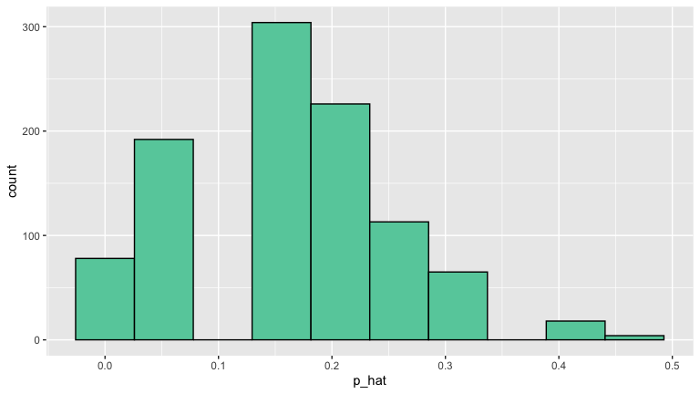

Question 5d
calculate the mean of the n = 15 sampling distribution, and the standard error of the n = 15 sampling distribution
p_hat_n15_1000rep %>%
summarize(M_p_hat = mean(p_hat),
SE_p_hat = sd(p_hat))
## # A tibble: 1 × 2
## M_p_hat SE_p_hat
## <dbl> <dbl>
## 1 0.159 0.0944

Question 6a
How does the standard error of the n= 15 sampling distribution compare to the standard error of the n = 50 sampling distribution?
Answer:
The standard error of the n=50 sampling distribution was about 0.052 while the standard error of the n=15 sampling distribution was about 0.094. So there’s a difference of about .042 between the two.

Question 6b
Explain any observed differences from Question 6a
Answer:
The n=50 sampling distribution had a smaller standard error than the n=15 sampling distribution because a larger sample size leads to fewer differences due to sample variation.

Question 7a
Use the rep_sample_n function to collect 1000 virtual samples of size n = 600. Note: BE SURE TO NAME YOUR SAMPLE SOMETHING NEW, TO ENSURE YOU CAN DISTINGUISH IT FROM THE n = 50, and n = 15 SAMPLES ABOVE!
set.seed(53)
n600_1000rep <- gss_14 %>%
rep_sample_n(size = 600, reps = 1000)

Question 7b
Calculate the proportion $\hat{p}$ of people who reported they were Divorced for each replicate of your n = 600 sampling and save it as you did before in the variable p_hat
set.seed(56)
p_hat_n600_1000rep <- n600_1000rep %>%
group_by(replicate) %>%
summarize(divorce_count = sum(marital == "Divorced"),
n = n()) %>%
mutate(p_hat = divorce_count / n)

Question 7c
calculate the mean of the n = 600 sampling distribution, and the standard error of the n = 600 sampling distribution.
p_hat_n600_1000rep %>%
summarize(M_p_hat = mean(p_hat),
SE_p_hat = sd(p_hat))
## # A tibble: 1 × 2
## M_p_hat SE_p_hat
## <dbl> <dbl>
## 1 0.162 0.0132

Question 7d
Was there more variability from sample to sample when we took a sample size of 600 or a sample size of 50? Explain what evidence you have for assessing this
Answer:
There was more variability from sample to sample when we took a sample size of 600 than when we took a sample size of 50. We know this because the SE of the n=600 sampling distribution was smaller, and SE is like a measure of variation.

Question 8
Which sampling distribution looked more normally distributed (bell shaped and symmetrical); the one built on n = 15, 50 or 600? Why?
Answer:
ggplot(p_hat_n600_1000rep, aes(x = p_hat)) +
geom_histogram(color = "black", fill = "aquamarine3", bins=15)
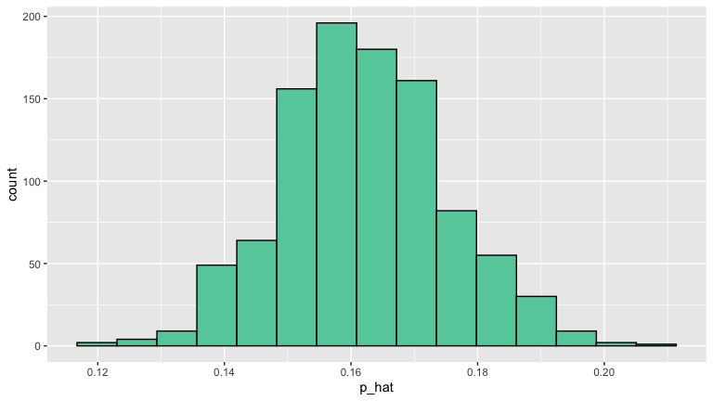
The n=600 sampling distribution looks the most normally distributed. This is because the Central Limit Theorem tells us that as the sampling size increases the distribution will become more normal.



Estimating $\hat{p}$ and the standard error of $\hat{p}$ from a single sample (revisited)
In most instances, we do not have access to the full population as we did in this GSS data; instead we have to take a sample to try to say something about the larger population. Furthermore, in the real world, we typically only take a single sample from the population, due to time or money constraints.
So how do we ESTIMATE a $\hat{p}$ and a standard error of $\hat{p}$ when we only have a single sample, and not 1000 repeated samples? As demonstrated at the very beginning of the Problem Set we:
- estimate $\hat{p}$ from the sample
- use the formula for the standard error of $\hat{p}$ below, to estimate SE based on a single sample
$${\hat{SE}}_{\hat{p}}≈\sqrt{\frac{\hat{p}×\left(1−\hat{p}\right)}{n}}$$

Question 9
Imagined we collected only a single small sample of 15 respondents like so:
set.seed(53)
n15_1rep <- gss_14 %>%
rep_sample_n(size = 15, reps = 1)
Following the example from the beginning of the Problem Set (roughly line 180ish), estimate the sample proportion $\hat{p}$ of people who identified as Divorced based on n15_1rep… AS WELL AS the standard error of $\hat{p}$
set.seed(49)
n15_1rep %>%
summarize(divorce_count = sum(marital == "Divorced"),
n = n()) %>%
mutate(p_hat = divorce_count/ n,
se_hat = sqrt(p_hat * (1 - p_hat) / n))
## # A tibble: 1 × 5
## replicate divorce_count n p_hat se_hat
## <int> <int> <int> <dbl> <dbl>
## 1 1 4 15 0.267 0.114
You should have gotten a value reasonably close to the estimate we made earlier from our sampling distribution for n = 15! Note that when you must estimate a standard error from only a single sample, the formula contains the sample size, n. The larger the sample size n, the larger the number in the denominator of the SE formula.

Question 10
Fill in the R Markdown table below with all the standard errors you computed for this problem set. In other words:
- Replace x with the standard error you obtained by taking the standard deviation of the n = 15 sampling distribution
- Replace a with the standard error you obtained for a single sample of n = 15 using the mathematical formula
- etc.
When you are done, make sure all the | in the table still line up so your results print out in a table!
This is a summary of your work!
Sample size n | SE via sd of sampling distribution | SE via one sample and formula
15 | 0.09437804 | 0.1141798
50 | 0.052215 | 0.04242641
600 | 0.01320748

Question 11
Based on what you observed for Question 10, IF you collected a single sample from 600 respondents, do you think the standard error will be smaller or larger than the one you calculated for n = 15. Explain your reasoning (Note: if you are not sure you can collect a sample and calculate the standard error)
Answer:
I think the standard error will be smaller for the single sample of 600 respondents. From observation I can see that the standard error in the one sample case for n=50 is smaller than the standard error in the one sample case for n=15, and I can also reason intuitively that larger samples tend to be more representative of their populations.

